Project Report

~ Grocery Android App

Using Kotlin Language

* ♦ Introduction

This app is build using Kotlin Language in Android Studio. This project is build with MVVM(Model View ViewModel) for architectural patterns. We have also used Room for Database. And Coroutines and RecyclerView for displaying list of items, which the user will enter. The app is User Friendly as the user can insert grocery items and delete as per their convenience.

* ♦ Project Introduction

This project is build to solve the user issues. As everything cannot be remembered, users frequently forget to buy the things they want to buy. This app can be helpful in such situations for users. As they can note down all the things that should be bought, So they cannot forget them. With the assistance of this app they can make the list of grocery items, so that you don’t forget anything.

♦ Technologies Used in this Project

* MVVM(Model View ViewModel) :
* Room Database
* RecyclerView
* Couroutines

♦ URL

* Google Developer Profile

<https://g.dev/fahemikhan>

* Github URL

<https://github.com/smartinternz02/SPSGP-67784-Virtual-Internship-Android-Application-Development-Fahemi>

* Demo URL

<https://github.com/smartinternz02/SPSGP-67784-Virtual-Internship-Android-Application-Development-Fahemi/blob/main/Grocery%20App.mp4>

♦ output screenshots

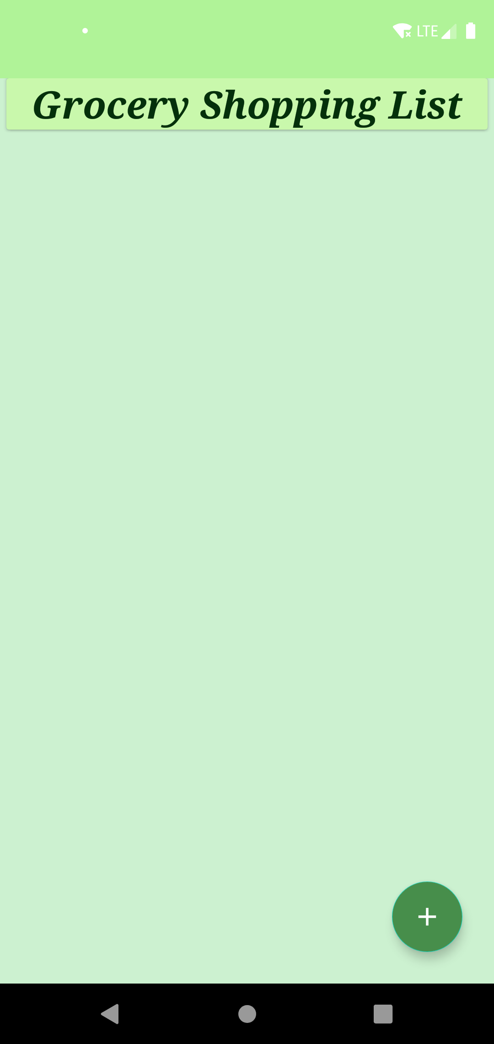 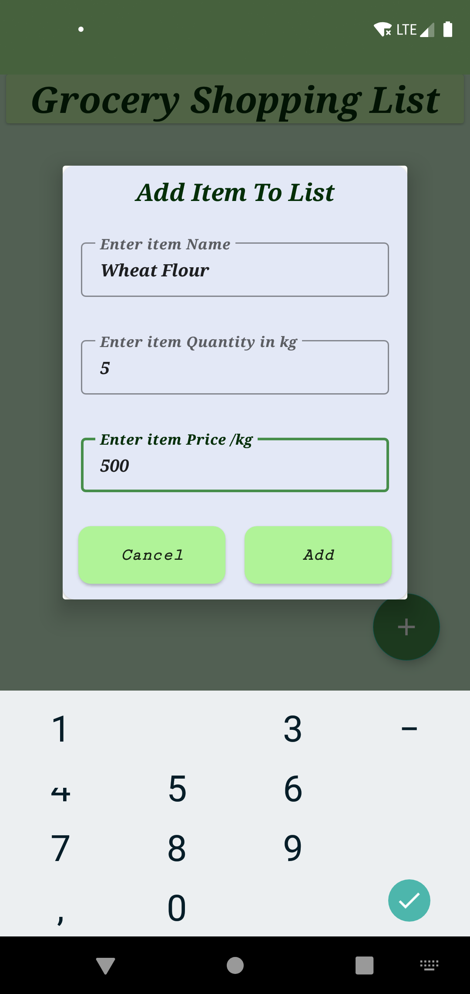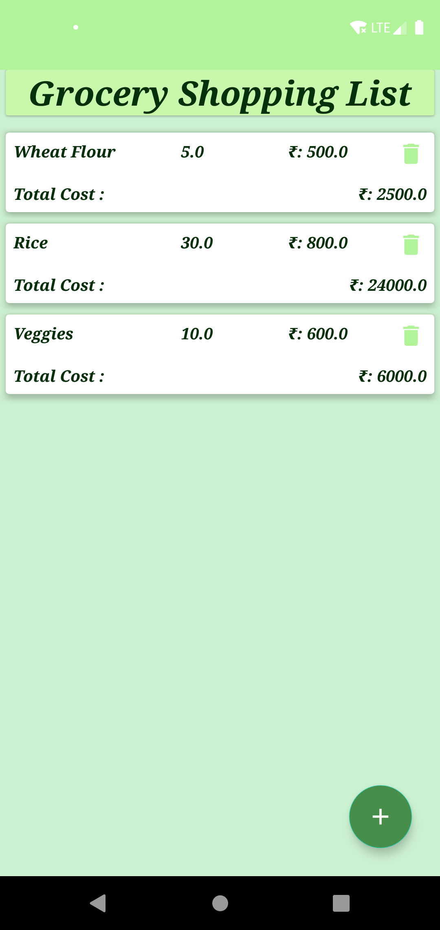

♦ Acknowledgement

First I would like to thank SmartInternz, for giving me the opportunity to do an internship. And also would like to thank the mentors for giving us this opportunity to learn new things. I have learned a lot new things, during this internsghip period. Thank you team SmartInternz for guiding us throughout the project session.

♦ Bibliography

* Google Developers

<https://developers.google.com>

* Android Developers  
  <https://developer.android.com>
* Wikipedia

<https://www.wikipedia.org>